**CS2041**

Information Management

Group Assignment

**Part 1**

**The National Library of Ireland**

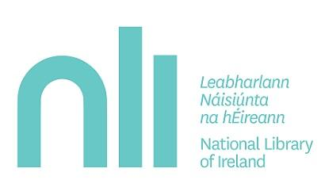

**Group 24**

Sharon Olorunniwo

Jack Donal Collins

Colman Kinane

Tom Wiśniowski

Fintan Gibney

**National Library of Ireland**

CS2041 - Information Management

Group 24

Group Report Part I

Introduction 2

Our Background Research & How we collected it 3

Undertaking the Task 4

UML Case Diagram 5

UML Use Case Diagram Scenarios 6

UML Class Diagram 8

UML Class Diagram Description 9

UML Activity Diagram – “*Request Consultation”* 11

UML Activity Diagram – “*Host Consultation”* 12

Ethics Canvas 13

Description of Ethics Canvas 14

Who Did What 14

Strengths & Weaknesses of UML Design 15

# Introduction

The National Library of Ireland is Ireland’s National Library and is under the remit of the Minister for Arts, Heritage and an Gaeltacht. The National Library provides a multitude of services to not only the Citizens of Ireland but to people from all over the world. The National Archives contain genealogy records dating back prior to the creation of the state.

**National Library of Ireland**

CS2041 - Information Management

Group 24

Group Report Part

# Our Background Research & How we collected it

Our Background research focussed on what the National Library actually does and more importantly how it does it. We used the National Library Website & Other Government resources extensively to conduct our research.

One of the first questions we asked ourselves was *“so what does the National Library actually do?*” When we think about any library, the first thing in our heads is “renting out books”. The National Library is actually completely different. The primary focus is to gather all material which relates to Ireland and its history and preserve it for future generations. Even if no one visited, the library would continue to collect and store all this information.

There are 5 main things that the National Library does in order to carry out its mission which is determined by Legislation under the authority of the office of the Minister for Arts, Heritage and an Gaeltacht.

1. The primary aims is to collect library materials, relating to Ireland and to provide an accurate record of Ireland's output in manuscript, print and other media for present and future users.
2. Holds the most comprehensive collection of Irish documentary material in the world. They subsequently store the materials and allow the general public to access the materials.
3. Organizes exhibitions, public lectures, and other events involving:  poetry, music,  theatre, children's storytelling, creative workshops, and others.
4. Providing a wide range of services for primary, post-primary, third level students, lifelong learners and educators.
5. Provides Genealogy Advisory Service for those beginning family history research.

So how does the Library gather all this material? There are three main ways;

1. **Legal Deposit** - most publishers in are obliged to deposit copies of their publications.
2. **Donation**- Generous individuals may endow a collection to the state or make a donation while they are alive.

1. **Purchase** - Everything which the library sees as valuable source of information, and which they couldn't attain through Legal Deposit is bought in the interest of the state.

Probably the most important thing about the National Library is that it is a closed stack reference library which means that books and other items can’t be taken out and must be ordered for consultation in reading rooms. To actually view material you need a Reader's Ticket, which you can get only if you're aged 16 years or older and which is valid for a maximum of 3 years. You can then order the material you wish to view, either online or in person, and when it's available you can come in to see it, sometimes you will be designated a certain day and in many occasions, you will be allocated to a particular room to view it in.

# Undertaking the Task

We decided to model how material is requested and accessed by Patrons. The reasons for this was because it was the most intricate system and would allow us to demonstrate to a high level how much goes on behind the scenes of a such a complex organisation. There are three methods of booking a viewing of a material;

1. Online,
2. Telephone,
3. In person.

We will tackle the problem by researching the libraries processes and by mapping the online method of booking a viewing for a material held by the library through the use of UML use case diagrams and UML class diagrams.

# UML Case Diagram../Downloads/Use%20Case%20Diagram.png

# UML Use Case Diagram Scenarios

**Requesting a material to view**

**Primary actor(s):**   Patron

                             National Library Login System

  Material Database

Librarian

**Precondition(s):** Valid Reading Ticket

Material is available

Space available in Reading Room

**Normal Scenario:**

1. Patron logs onto the NLI online order system
2. The patron enters their desired material type to view
3. Search material call(ID) number in NLI Catalogue in order to complete the first section of the online order form
4. The patron enters the material Author and Title
5. The patron enters Reading Ticket number to validate their ticket
6. The patrons order is then submitted to the National Library Ireland
7. The material database is then updated
8. The patron arrives at the library desk
9. The librarian validates the patrons Reader Ticket
10. The librarian gives the patron their ordered material
11. The Librarian then assigns the Patron to a Reading Room
12. The Patron completes use of material
13. The Patron returns the material to the librarian
14. The librarian places the material back on the stack
15. The Material Database is then updated

**Special Scenario:**

1. Patron has the option of booking a genealogy consultation
2. The patron requests a consultation at the librarian desk
3. The Librarian checks the availability of a consultation session
4. If there is a slot available the Librarian hosts a consultation session for the Patron

**Error Scenario:**

1. **Invalid Reading Ticket**
2. Patron enters the material information in the online application
3. The Patron enters their Reading Ticket number
4. The Patrons Reading Ticket comes back as Invalid
5. The Patron renews their Reading Ticket in person at the National Library
6. **No Reading Ticket**
7. Patron enters the material information in the online application
8. If the Patron does not have a Reading Ticket they fill out the online application after entering the material information
9. **Material is not available/Access Denied**
10. Patron enters the material information in the online order application
11. If the requested material is not available the Patron receives an error message
12. The Patron then has the choice to be put on a waiting list for the requested material
13. **No Reading Spaces available**
14. Patron enters the material information in the online order application
15. If the Reading space is not available the Patron receives an error message
16. The Patron then has the choice to be postpone their viewing to a later date

# UML Class Diagram../Downloads/UML%20Class%20Diagram.png

# UML Class Diagram Description

The National Library model describes the main classes and relationships which could be used during the analysis phase to better understand the National Library’s Management System.

Every library has the following attributes: Address, Establishment Date, Name etc, all of which are in our library class. The library employs more than one librarian and the librarian works for one library, hence the cardinality of one to more than one. There is a composition between the library and the librarian because you cannot have a librarian without a library.

In order to place an order request to view a material in the National Library, a valid Reading Ticket is a requirement, hence we have a composition between the Reading Ticket and Material Request class. The Reader Ticket is only created for one Library and the National Library has multiple Readers Tickets on record for their multiple visitors. Therefore the cardinality between the Reader Ticket and the library is 1 and 0..* For every Patron there is one Reader Ticket. In order to apply for a Reader's Ticket the Patron must supply the following information: Date of Birth, Name, Photographic ID, address. The following attributes are included in the Reader Ticket class, only the Name, Photo, Date of Birth are the pieces of information that is public in the Reader's Ticket class the other attributes have restricted visibility. The Reader's Ticket has a issue and expiry date. The cardinality between the Reading Ticket and Material Request classes is between 0...3, this is because a Patron can only order up to 3 items to view at a time.

Without a material request there would be no reason to book a reading room hence the composition between the material request class and the Reading_Room Booking class.

When a material order request is processed and approved the material database is updated. In the National Library the materials are separated into seven categories: Maps, Newspaper, Book, Journal, Newspaper, Manuscript and Musical Score. For this reason we decided to use subclasses instead of aggregation relationships.This was because we felt subclasses were more appropriate and made sense in regards to material organization in the database and library. The material category subclasses inherit from the material class. Regardless of type, every single item in the National Library available for viewing in the National Library has the following attributes: ItemID, ItemName, ItemDescription, ItemPermissionLevel, ItemSource. The database class must be able to notify the librarian and patron if a particular material is unavailable for a viewing. Once the order has been assigned and confirmed the librarian allocates a reading room to the patron. The cardinality between Room_Booking class and Reading Room location class is one and one because every Reading_Room booking only books one location.

The library also offers consultation on genealogy records for patrons who request it. The Consultation_Booking class requests availability of a library consultant to host the viewing for the patron. The Library_Consultant confirms the consultation availability. The cardinality between the Consultation_Booking class and Library_Consultant class is one and one. There is a composition relationship between the Consultation_Booking class and Consultation class, without a consultation booking there is no consultation session.

# UML Activity Diagram – “*Request Consultation”*

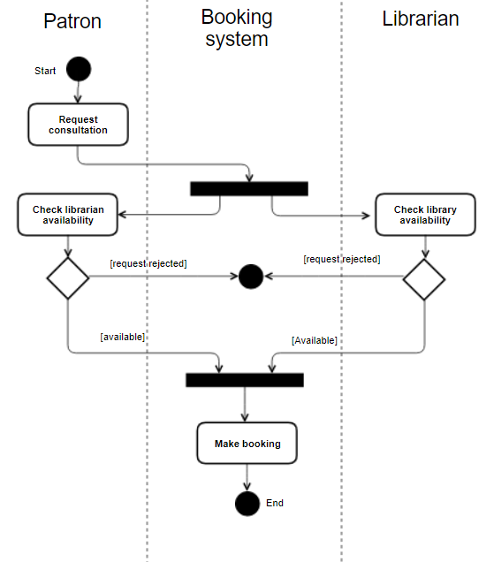

Description

The request consultation is a meeting between a patron of the library and a librarian about genealogy. The process starts with the patron requesting the consultation. The request triggers the system to check the availability of the librarian and for space in the library. These checks return either a negative or positive result. If both checks come back positively then the booking is made. If either is negative the booking cannot be made.

# UML Activity Diagram – “*Host Consultation”*

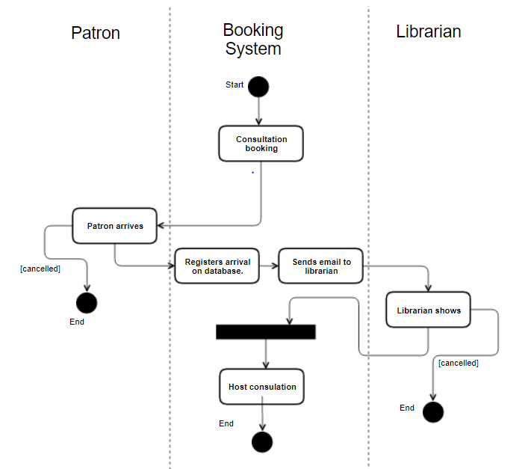

Description

In the aftermath of the previous UML activity diagram when a booking is made the consultation must be hosted. It begins with a successful booking and then it depends on both the librarian and the patron showing to the allocated appointment. If they both show the consultation is hosted.

# Ethics Canvas../../../../../Desktop/Screen%20Shot%202017-11-12%20at%2016.21.05

# Description of Ethics Canvas

In General Terms Libraries tend to be seen as quite ethical organisations who merely persevere data in so far as it can, so as to be a reference for current and future generations. With respect to the National Library, decisions about what kind of data(Census, Genealogy records & Legal Deposit Laws) are principally decided by the state and the Library has no legal influence over it.

One of the biggest challenges facing Libraries and particularly the state, is the storage of digital content. This type of content is often edited without the original data being preserved. For example if the state updated a website it might not make a previous version of the site available online. This causes problems in a historical context as the

**Individuals & Groups Affected**

The Library has many stakeholders, ranging from a University Academic to Book & Material publishers. Publishers have to manage their legal responsibility to the Library while Academics are the most common users of the Library facility.

**Behaviour**

Historically The Library has been able to store all major documents of historical importance. However, with the advent of the internet, over the next few years the library will have to look at becoming a permanent digital store of Information. Storing copies of webpages which are of importance to the state. Legal Deposits may also be extended to E-Books.

**Relations**

The relationship the National Library has with the people of Ireland is incredibly important, It allows people to find out more about their past, learn more about Irish history or what the opinions of the people of Ireland were at certain points in our history.

**WorldViews**

The Library has a legal and moral obligation to remain apolitical and to record and maintain a record of all publications regardless of their nature. It is incredibly important that the library retains the highest level of ethics when it comes to maintaining and recording documents which could be seen as distasteful by the majority of the population. For example, In Germanys case it is incredibly important they maintain Nazi propaganda documents even though such documents don’t represent the beliefs of the people they still form an integral part of that nations history.

# Who Did What

Introduction & Background Research – Jack Collins & Tom Wiśniowski

UML Case Diagram – Whole Group Contributed

UML Case Diagram Scenario Descriptions – Sharon Olorunniwo

UML Class Diagram - Whole Group Contributed

UML Class Diagram Description - Sharon Olorunniwo

UML Activity Diagrams & Descriptions – Colman Kinane

Ethics Canvas & Ethics Canvas Description – Jack Collins

Strengths & Weaknesses of Design – Colman Kinane

# Strengths & Weaknesses of UML Design

Strengths

Weaknesses